input_layer_size = 400

hidden_layer_size = 5

num_labels = 10

max iter = 200

Training Set Accuracy: 86.240000

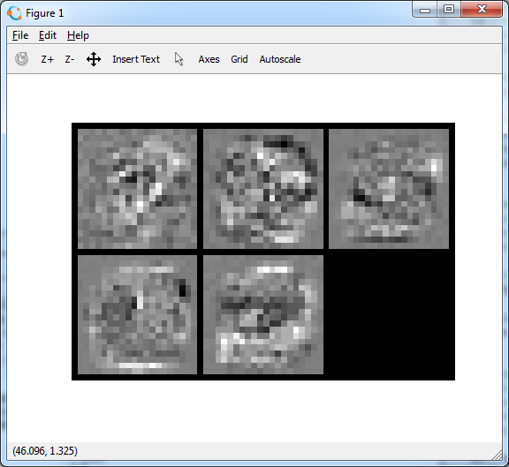

input_layer_size = 400

hidden_layer_size = 10

num_labels = 10

max iter = 200

Training Set Accuracy: 96.640000

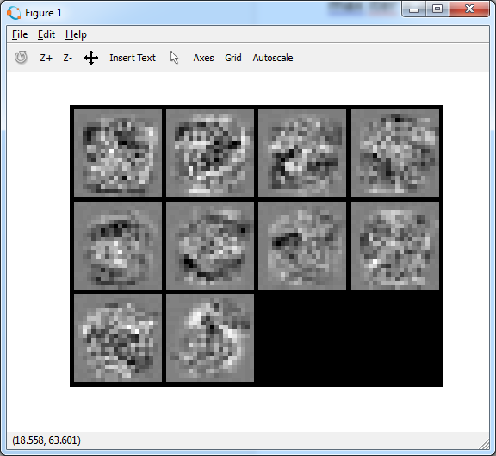

input_layer_size = 400

hidden_layer_size = 15

num_labels = 10

max iter = 200

Training Set Accuracy: 98.280000

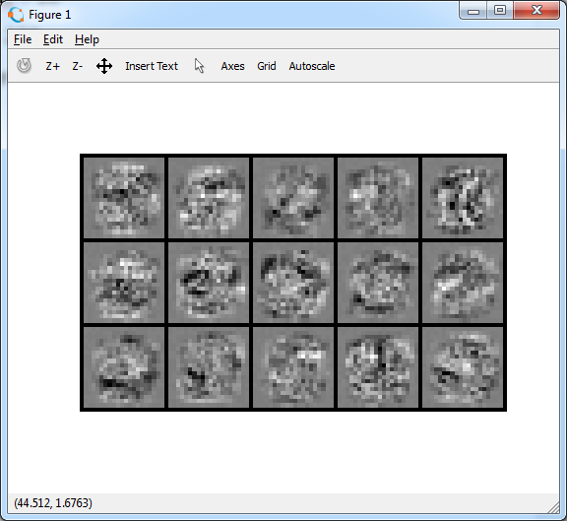

input_layer_size = 400

hidden_layer_size = 20

num_labels = 10

max iter = 200

Training Set Accuracy: 98.920000

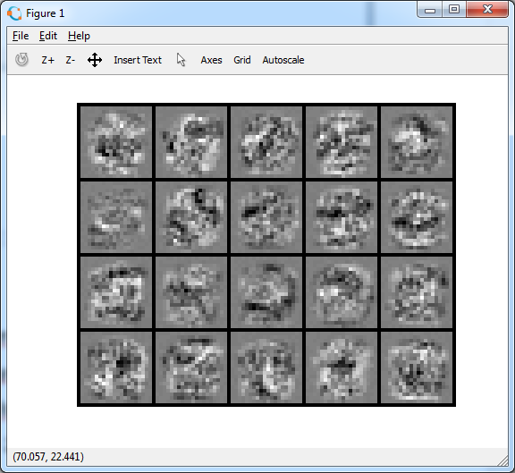

input_layer_size = 400

hidden_layer_size = 25

num_labels = 10

max iter = 200

Training Set Accuracy: 99.320000

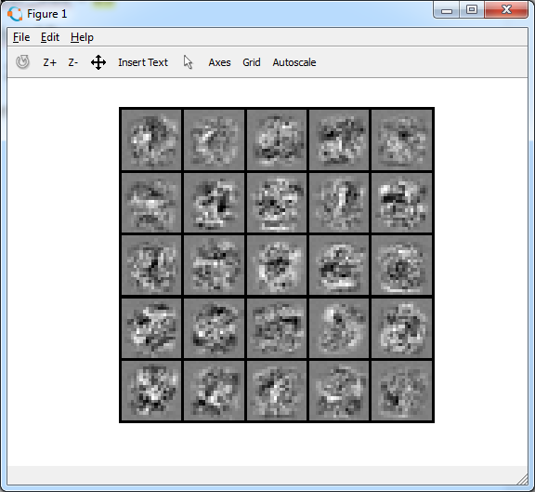

input_layer_size = 400

hidden_layer_size = 30

num_labels = 10

max iter = 200

Training Set Accuracy: 99.380000

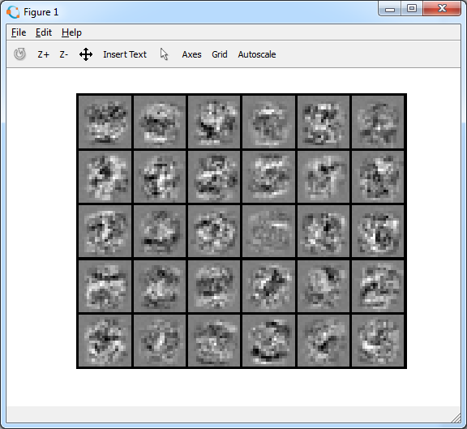

input_layer_size = 400

hidden_layer_size = 35

num_labels = 10

max iter = 200

Training Set Accuracy: 99.460000

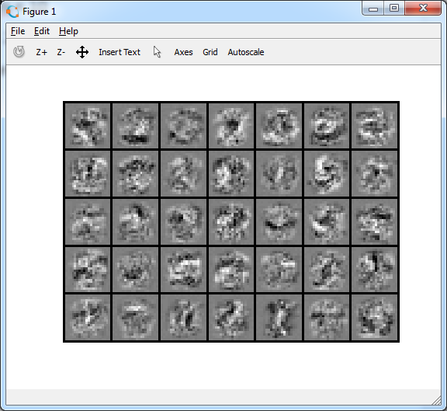

input_layer_size = 400

hidden_layer_size = 40

num_labels = 10

max iter = 200

Training Set Accuracy: 99.660000

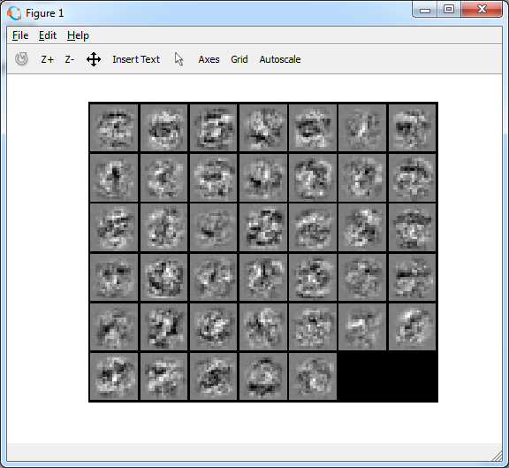

input_layer_size = 400

hidden_layer_size = 45

num_labels = 10

max iter = 200

Training Set Accuracy: 99.620000

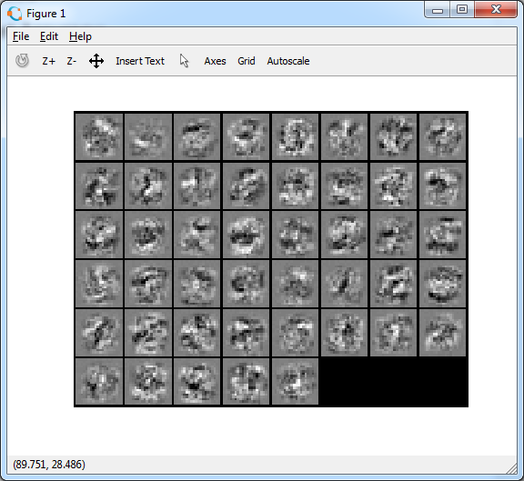

input_layer_size = 400

hidden_layer_size = 50

num_labels = 10

max iter = 200

Training Set Accuracy: 99.740000

